

**Indian Institute of Technology, Indore**

**CS 257**

**DBIS Project**

**Supermarket**

**Submitted by :**

**M Mounika (160001036)**

**Neha Nagendra (160001042)**

Project Description:

A database is a collection of interrelated data containing information related to an enterprise. Databases are widely used in almost every field. One of them is a Supermarket database. Supermarket like BigBazar, D-mart have heavy data to store which is used quite frequently. The aim of our project is to make a user interface (website) for the supermarket to store it’s daily transactions and manage the employees. A customer can also access product details using this website.

E-R Analysis:

1. **Entity Relation for Employee details:**
2. Employee (E)
3. Employee id
4. Employee name
5. Joining date
6. Salary
7. Address
8. Phone number
9. Leaving date (if employee left the job)
10. Department name
11. Designation (E)
12. Designation id
13. Designation name
14. Perks
15. Emp_Desig (R)
16. Promotion (E)
17. Promotion id
18. Previous Designation
19. Present Designation
20. Emp_Prom(R)
21. Date of promotion
22. **Entity relation for transaction details**
23. Transaction (E)
24. Transaction id
25. Number of products
26. Amount
27. Final amount
28. Counter
29. Product (E)
30. Product name
31. Product id
32. Price
33. Stock
34. Type
35. Brand name
36. Prod_Trans (R)
37. Quantity
38. Section (E)
39. Section id
40. Section name
41. Offer given
42. Prod_Sec (R)
43. Customer (E)
44. Customer id
45. Customer name
46. Address
47. Phone number
48. Offers
49. Cust_Trans (R)

Transformation of ER model into tables:

**Create tables:**

*create table* ***designation****(*

*desig_id int primary key,*

*desig_name varchar(50),*

*perk int);*

*create table* ***Employee****(*

*Emp_id int primary key,*

*desig_id int,*

*Name varchar(50),*

*Dept_name varchar(50),*

*join_date date,*

*salary int,*

*password int ,*

*leaving_date date,*

*foreign key (desig_id) references designation(desig_id));*

*create table* ***emp_phoneno****(*

*Emp_id int,*

*phoneno long,*

*foreign key (Emp_id) references Employee(Emp_id));*

*create table* ***emp_Address****(*

*Emp_id int,*

*Hno varchar(50),*

*Area varchar(50),*

*locality varchar(50),*

*city varchar(50),*

*state varchar(50),*

*pincode long,*

*foreign key(Emp_id) references Employee(Emp_id));*

*create table* ***promotion****(*

*prom_id int,*

*Emp_id int,*

*prev_desig varchar(50),*

*pres_desig varchar(50),*

*foreign key(Emp_id) references Employee(Emp_id));*

*create table* ***transaction****(*

*trans_id int primary key,*

*no_of_prod int,*

*counter int,*

*Act_amount int,*

*final_amount int);*

*create table* ***customer****(*

*cust_id int primary key,*

*name varchar(50),*

*offer int,*

*check (offer < 100));*

*create table* ***cust_phoneno****(*

*cust_id int ,*

*phoneno long,*

*foreign key (cust_id) references customer(cust_id));*

*create table* ***cust_Address****(*

*cust_id int,*

*Hno varchar(50),*

*Area varchar(50),*

*locality varchar(50),*

*city varchar(50),*

*state varchar(50),*

*pincode long,*

*foreign key(cust_id) references customer(cust_id));*

*create table* ***section****(*

*sec_id int primary key,*

*sect_name varchar(50),*

*offer int,*

*check (offer<100));*

*create table* ***product****(*

*prod_id int primary key,*

*name varchar(50),*

*type varchar(50),*

*price float,*

*stock int,*

*sec_id int,*

*brand_name varchar(50),*

*foreign key (sec_id) references section(sec_id));*

*create table* ***prod_trans****(*

*trans_id int,*

*prod_id int,*

*quantity int,*

*foreign key (trans_id) references transaction(trans_id),*

*foreign key (prod_id) references product(prod_id));*

*create table* ***cust_trans****(*

*cust_id int,*

*trans_id int,*

*foreign key (trans_id) references transaction(trans_id),*

*foreign key (cust_id) references customer(cust_id));*

**Triggers:**

**Trigger 1:**

*delimiter //*

*create trigger Product_update*

*after insert on prod_trans*

*for each row*

*begin*

*update Transaction*

*set no_of_prod=no_of_prod+new.quantity*

*where transaction.trans_id=new.trans_id;*

*end //*

*delimiter ;*

**Trigger 2:**

*delimiter //*

*create trigger setdesignation*

*after insert on promotion*

*for each row*

*begin*

*update employee*

*set desig_id=*

*(select desig_id from designation where desig_name = new.pres_desig)*

*where employee.emp_id=new.emp_id;*

*end //*

*delimiter ;*

**Constraints:**

* Offer can never be more than or equal to 100.
* A customer cannot buy the product if it’s stock = 0.
* Only HR manager can add new employees and enter promotion, leaving date of an employee.

**Features:**

Page 1:

First page has 2 options for the user. If he is an employee he has to click “Employee” button. If he is a customer he has to click “Customer” button.

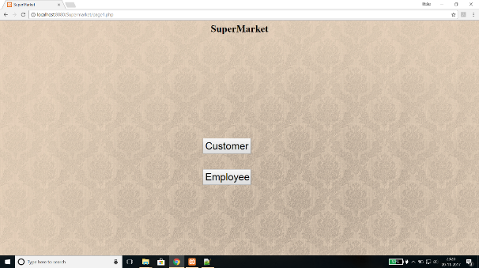

Page 2:

The customer button on previous page redirects the customer to this page where he can see all the list of the products available in the supermarket. The go back button on this page takes you back to the main page.

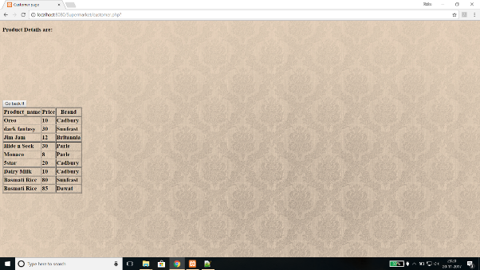

Page 3:

This page lets you login to your dashboard (if you are an employee). Employee has to enter employee id and password which will be given by the authorities when he joins the company. If correct details are entered then you are redirected to employee dashboard page. If wrong details are entered a message is popped “Enter correct details”.

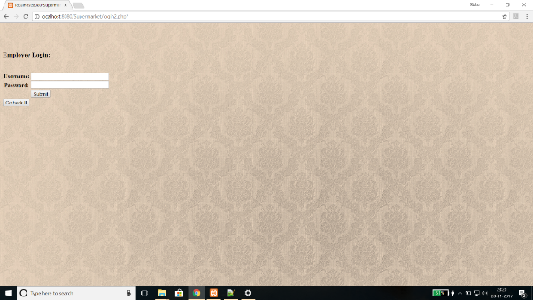

Page 4:

This is employee dashboard page where employee can do multiple things.

If the employee is a HR Manager he will extra options to add new employees, enter promotion details, update leaving date of employee who left the job and see all the employee details. Any employee can update stock details and see product details. If the employee works in sales department he an option to enter new transaction. He can do billing and update the transaction in database. An employee can update his own phone number and address details in the database.

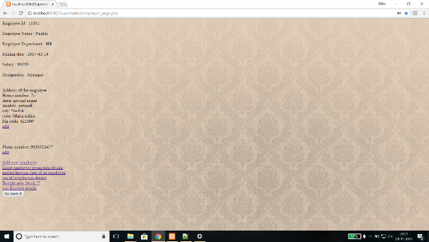

Page 5:

In this page employee can enter new employee details. He has to enter full information about the employee. It is done using sql insert command.

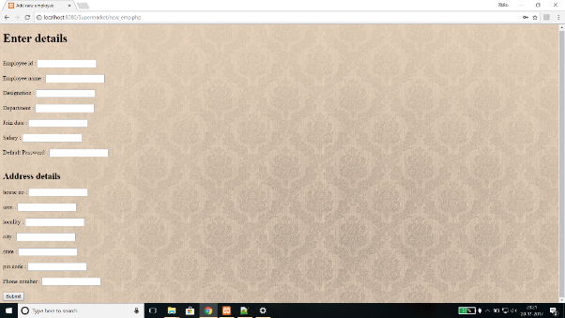

Page 6:

In this page employee can enter an employee’s promotion details. He has to enter employee id, new designation and previous designation details and increased salary about the employee. These details are updated in the database using sql update statement.

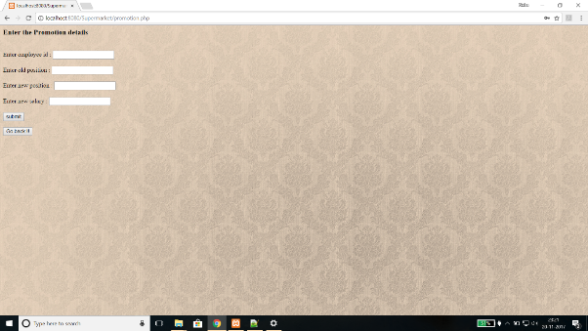

Page 7:

In this page employee can enter an employee’s leaving date details. He has to enter employee id, leaving date of the employee. These details are updated in the database using sql update statement.

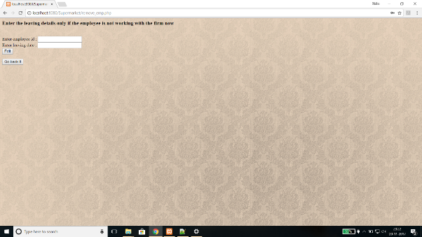

Page 8:

In this page employee can see his co-workers details. This option is available only for HR Manager.

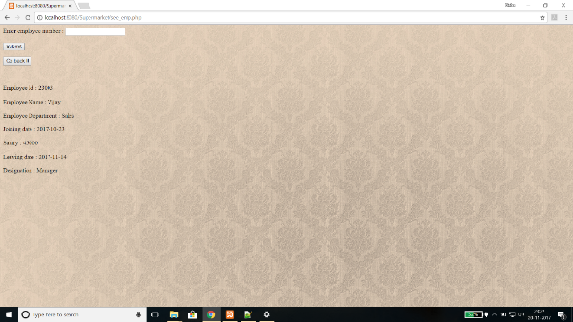

Page 9:

In this page an employee can update stock details of any product. It is done using sql update command.

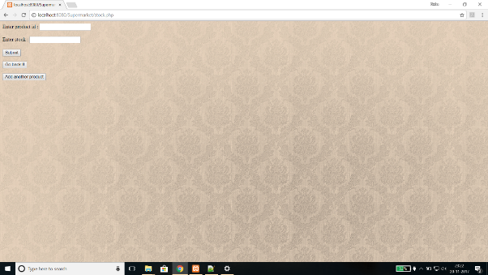

Page 10:

If an employee wants to have a look of all the product details, he can do that on clicking View product details. Then he/she will be directed to this page. This page include all details of product like name, price, brand etc.

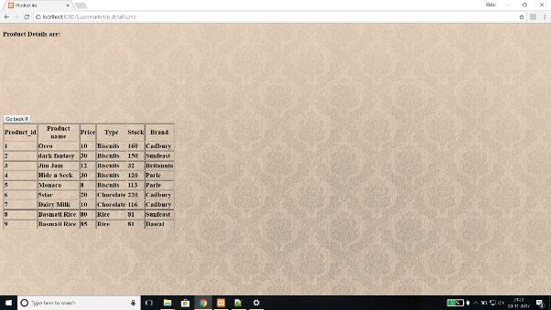

Page 11:

If an employee wants to edit his address he can do that using this page. It will be updated in the database.

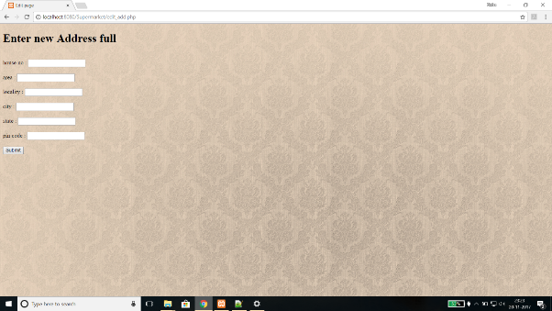

Page 12:

If an employee has changed his phone number, he can update it using this page.

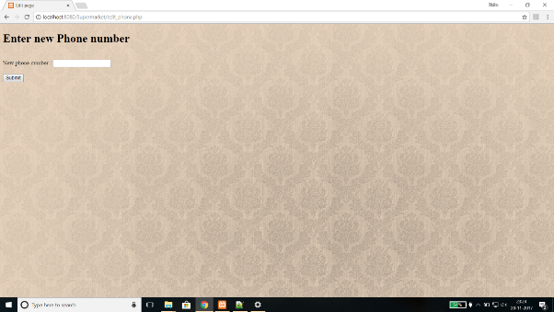

Page 13:

If an employee wants to add a new transaction record, he can add it on clicking ‘add new transaction record’ then he will be directed to this page. This page asks the employee for the counter number and customer_id. If that customer is registered then he can enter customer_id for extra benefits.

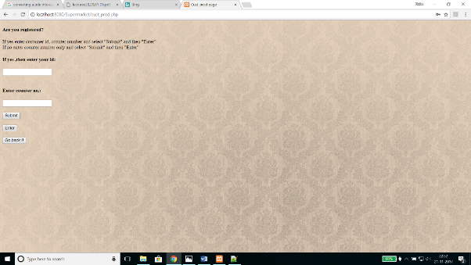

Page 14:

After entering the customer_id and counter number, the employee will be directed to this page where he can enter the product details that are bought by a customer.

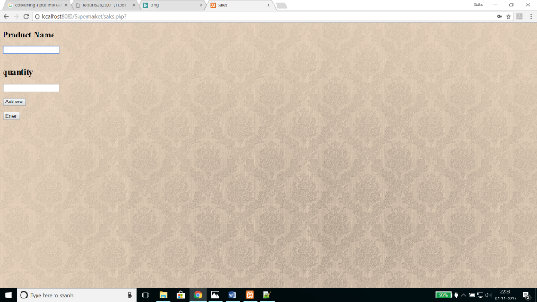

Page 15:

After entering the product list in the previous page, employee (cashier) will be directed to this page. In this page the total cost of all the products bought by a customer is shown.

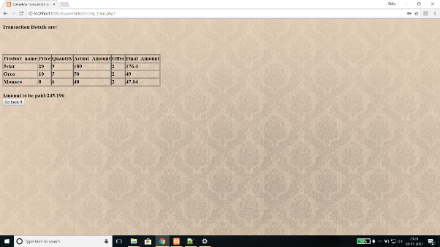

Page 16:

If an employee wants to look at all the transactions performed, he can visit this page. This page contains all transaction details done in that supermarket.

